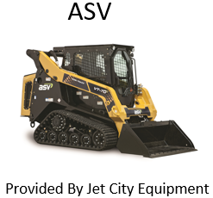 | Franssen Motors dba Jet City Equipment  33345 SR 20  Oak Harbor, Wa 98277
SALES:
John Stevenson
(509) 727-5057
Jstevens100@msn.com

SERVICE:
Andy Bighouse
(360) 675-4441
Andy@jetcityequipment.com

State Contract Machines
Contract Item Number | Description | Model | Price | Deducts
Item 5 | Skid Steer Wheel Loader | ASV RT-60 | $36,003.00 | 4-1 Bucket Deduction ($3,560.00)
Item 6 | Compact Track Loader | ASV VT-70 | $54,442.00

Parts and Accessories
Type | Manufacturer | Catalog year/Date | % discount
Original Equipment Repair Parts | ASV | 2017 | 0%
Original Equipment Attachments/Accessories | ASV | 2017 | 0%
Aftermarket Attachment/Accessories | Erskine | 2017 | 15%
 | Paladin | 2017 | 25%

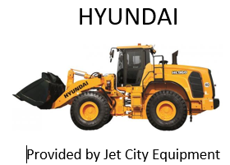 | Franssen Motors dba Jet City Equipment  33345 SR 20  Oak Harbor, WA 98277
SALES:
John Stevenson
(509) 727-5057
Jstevens100@msn.com

SERVICE:
Andy Bighouse
(360) 675-4441
Andy@jetcityequipment.com

State Contract Machines
Contract Item Number | Description | Model | Price | Deducts
Item 1 | Front Loader; 2.5 yard | Hyundai HL940 | $140,420.00 | Std front fenders in lieu full deduct ($1,350)  Std rear fenders in lieu full deduct ($1,350)  Delete 4in1 bucket ($10,650)
Item 2 | Front Loader; 3.5 yard | Hyundai HL960 | $198,470.00 | Std front fenders in lieu full deduct ($1,406)  Std rear fenders in lieu full deduct ($1,406)  Delete 4in1 bucket ($15,726)
Item 3 | Front Loader; 5 yard | Hyundai HL970 | $292,428.00 | Delete ride control ($2,645)  Std front fenders in lieu full deduct ($1,575)  Std rear fenders in lieu full deduct ($1,575)  Delete 4in1 bucket ($20,550)
Item 7 | Front Loader; 3 yard | Hyundai HL955 | $158,310.00 | Std front fenders in lieu full deduct ($1,240)  Std rear fenders in lieu full deduct ($10,650)
Parts and Accessories
Type | Manufacturer | Catalog year/Date | % discount
Original Equipment Repair Parts | Hyundai | 2017 | 0%
Original Equipment Attachments/Accessories | Hyundai | 2017 | 0%
Aftermarket Attachment/Accessories | Erskine | 2017 | 15%
 | Paladin | 2017 | 25%

