
Updated 12-05-19
Propane, Auto Gas (LPG), Parts and Service

Pricing and Ordering
Purpose
This statewide master contract is for “as-needed” Industrial, Commercial Propane, Parts and Service and; Auto Gas (LPG), Parts and Service only, it does not include any gasoline-type fuel products intended for automotive use. This contract addresses the most commonly utilized propane, auto gas and related services by state government.
Purchasers
This contract is available for use by all Washington state agencies and authorized parties to the Master Contracts Usage Agreement (MCUA), including institutions of higher education, cities and counties, other political subdivisions or special districts, and nonprofit corporations. Their orders are subject to the same contract terms, conditions and pricing as state agencies.
While use of the contract is optional for political subdivisions and nonprofit corporations authorized by the MCUA, these entities’ use of the contracts can significantly increase the purchase volume. DES accepts no responsibility for orders or payment by MCUA members.
MCUA members: https://fortress.wa.gov/ga/apps/ContractSearch/MCUAListing.aspx
Contract term: |  | Effective 02-01-2019 through 04-30-2027.
Estimated value: |  | Approximately $1,500,000.00 annually
Delivery time: |  | Three (3) Calendar Days After Receipt of Order (ARO)
Payment terms: |  | Net 30 days
Purchasing cooperative members: |  | Washington Master Contract Usage Agreement purchasers (MCUA)
 | DES Contract Specialist: |  | Alec La Brayere  Contracts and Procurement  (360) 489-4484  alec.labrayere@des.wa.gov

How to use this contract:
Only authorized Master Contract Usage Agreement (MCUA) purchasers are entitled to procure Propane, Auto Gas (LPG), Parts and Service under the authority of Contract 02318.
There are two things you need to know before starting to use this contract:
- How many tanks you have, where they are and who owns them. Do you own them, lease them or some combination?
- You must know what your Estimated Annual Sales Volume is to determine the correct volume bracket used for “Adder” prices or, the price per gallon the contractor will charge for service and delivery. Your Estimated Annual Sales Volume may be obtained through your Financial or Facilities offices or, from your current propane provider.
- Verify that your agency is an authorized user of DES Master Contracts. Washington Governmental entities not listed are not entitled to use this contract until an MCUA agreement is in effect.
- Recommended steps for Contractor selection if there are multiple contractors listed within your delivery regions:
- Review the state map to identify the appropriate region where the contract services are required.
- Click on the associated regional link below to see all of contractors within region selected.
- Select a contractor and click on the Contact information tab to review contractor’s information (i.e., address, contact personnel, etc.).
- Click on the contactor’s price spreadsheets to review their Adder pricing and compare pricing between the contractors to ensure the best value for your location.
- Customer Account Information:
- Even if you have conducted prior business with any of the contractors, you must update your account to ensure accuracy of contact information, addresses, phone numbers and if your agency is tax exempt.
- The contractor may not automatically provide state contract pricing so customers must specify that they want state contract pricing or they risk being liable for non-contract prices, which are likely to be much higher.
- Review the DES weekly Propane price update. This page displays the current the weekly propane contract average price per gallon. This amount per gallon listed on this page must be added to the Contractor’s “Adder” price per gallon in your volume bracket listed in their Regional Price Pages to determine the total price per gallon.

DES encourages customers to review the terms, conditions and services provided by the various contractors to determine the best overall fit for their agency’s needs. If clarification or further information is required, contact the contractors directly.
During your contractor selection process, you may choose to interview a new contractor. They must schedule a site assessment and although you may know your location’s needs, you may find the additional expertise of the industry to be of great value towards your final purchase decision.
Delivery Completion: Delivery shall be completed only when propane has been shipped F.O.B. Destination and placed into the Purchaser’s owned or rented propane storage tank(s).
Minimum Order Requirements: Although there shall be no minimum order quantity, Purchasers shall order reasonable quantities based on the size of their storage tank(s)

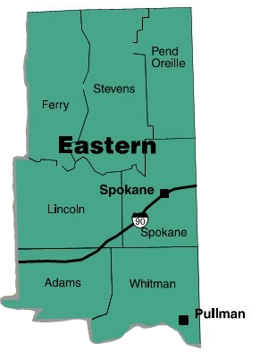
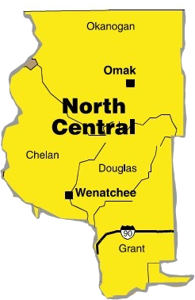
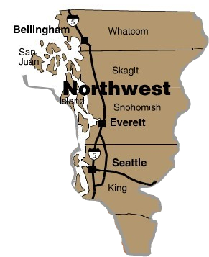
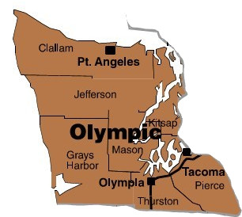
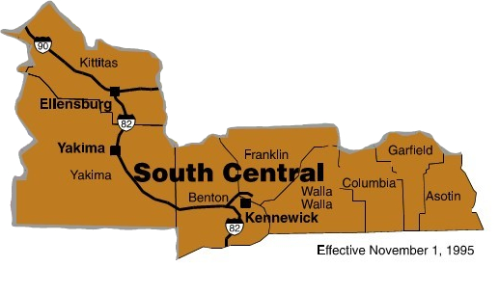
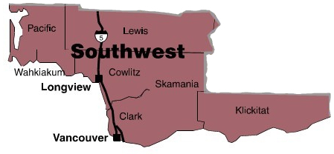

Contractor Listing by Region
Northwest | North Central
Blue Star Gas (Renewable Propane)  Ferrellgas  Ferrellgas (Renewable Propane) | AmeriGas  Ferrellgas  Ferrellgas (Renewable Propane)

Olympic | Southwest
Blue Star Gas (Renewable Propane)  Ferrellgas  Ferrellgas (Renewable Propane) | Blue Star Gas (Renewable Propane)  Ferrellgas  Ferrellgas (Renewable Propane)

South Central | Eastern
AmeriGas  Ferrellgas LP  Ferrellgas (Renewable Propane)  Yakima Coop | AmeriGas  Ferrellgas  Ferrellgas (Renewable Propane)

Contractor’s Profile

AmeriGas Propane, L.P.
 | Contractor Information
 | AmeriGas Propane, L.P.  Business Name  460 N Gulph Road  Address  King of Prussia, PA 19406  City, State, Zip Code | Indicate entity type (LLC, Corp., etc.): | Partnership
 |  | State of registration/incorporation: | Delaware
 | Wash. Dept. of Revenue Registration No. Unified Business Identifier (UBI): | 602-697-659
 | Federal Tax ID No. (TIN): | 23-2787917
 | Is your firm certified as a minority or woman owned business with OMWBE? | Yes No
 | Is your firm a self-certified Washington State small business? | Yes No
 | Is your firm certified as Veteran Owned with Washington State Department of Veteran Affairs? | Yes No

Contact for Account Set Up and Commencement of Service | National Account Representative/Customer Service
Implementation Projects Coordinator  Email: laura.scoufield@amerigas.com  Phone: 1-888-528-9475, extension 13145 | Name: Molly Serago  Email: molly.serago@amerigas.com  Phone: 1-888-528-9475 x 13138
24/7/365 Emergency Service | Accounts Receivable Analyst, Local Servicing Office
Phone: 1-888-528-9475  Option 1: for gas leaks  Option 2: for propane delivery or service | Phone:1-888-528-9475

Price spreadsheets |  | Will Call/Service Locations
PURCHASE CARDS
Please indicate which types of purchasing (credit) cards are accepted (note: any card fees must be included in the unit price of the bid):
Visa Master Card American Express Discover Other:
Contract Management Points of Contact for DES use
Authorized Representative  Name: Kathy Prigmore  Email: kathy.prigmore@amerigas.com  Phone: 610-337-7000 | Contract Administrator  Name: Dawn Stevenson  Email: dawn.stevenson@amerigas.com  Phone: 610-768-3601

Back to Contractor Listing By Region

Contractor’s Profile

Blue Star Gas – Seattle Co.

Contractor Information
Blue Star Gas – Seattle Co.  Business Name  10802 E. Marginal Way South  Address  Tukwila, WA 98168  City, State, Zip Code | Indicate entity type (LLC, Corp., etc.): | Corporation
 | Indicate state of registration/incorporation: | Washington
Wash. Dept. of Revenue Registration No. Unified Business Identifier (UBI): | 603-068-162
Federal Tax ID No. (TIN): | 27-5206199
Is your firm certified as a minority or woman owned business with OMWBE? | Yes No
Is your firm a self-certified Washington State small business? | Yes No
Is your firm certified as Veteran Owned with Washington State Department of Veteran Affairs? | Yes No

Ordering/Sales Points of Contact
Name | Phone Number | E-mail | Area of Responsibility
Christina Grabo  Auto gas Sales and Core Sales | 206-379-2031 | cgrabo@bluestargas.com | Clark, Cowlitz, Island, King, Pierce, Skagit, Snohomish, Thurston, Whatcom, Yakima
Price Spreadsheets
Will Call/Service Locations
Plant Locations
Propane, Parts and Service will be provided to Purchaser’s delivery locations from the following bidder owned plants in the performance of this contract in the event of contract award: Unless otherwise noted, orders will be placed with these plants.
Company Name: | Blue Star Gas – Seattle Co. |  | Company Name: | Blue Star Gas – Salem Co.
Address: | 10802 E. Marginal Way S., |  | Address: | 3837 Portland Road NE
City/State/Zip: | Tukwila, WA 98168 |  | City/State/Zip: | Salem, OR 97301
Plant Manager: | Seth Murphy |  | Plant Manager: | Kirk Chaney, Director of Operations
Phone: | 206-762-2583 |  | Phone: | 503-391-2737
Counties served from this plant: | King, Pierce, Snohomish, Thurston, Whatcom, Yakima |  | Counties served from this plant: | Clark, Cowlitz

Company Name: | Vanderyacht Propane  Federal Tax ID: 91-1623038 |  | Company Name: | Blue Star Gas – Autogas Public Locations
Address: | 1636 Walton Drive |  | Address: | (See table below)
City/State/Zip: | Burlington, WA 98233 |  | City/State/Zip:
Plant Manager: | Contact: Seth Murphy |  | Plant Manager: | Seth Murphy
Phone: | 206-762-2583 |  | Phone: | 206-762-2583
Regions served from this plant: | Skagit, Island |  | Regions served from this plant: | (See table below)

Blue Star Gas Autogas Cardlock Refueling Sites
WASHINGTON | WASHINGTON | OREGON
Around The Sound- TransPro | Kirkland 76 Station | Dollar Park N Fly
9825 183rd Way SW | 12235 NE 116 St. | 6455 NE 82nd Ave.
Rochester, WA 98579 | Kirkland, WA 98034 | Portland, OR 97220
Andy’s Chevron | Southcenter Chevron | Fastrak Fuel Mart
20010 Ballinger Way NE | 16200 West Valley Hwy | 2431 NE Broadway St.
Shoreline, WA 98155 | Tukwila, WA 98188 | Portland, OR 97232
Blue Star Gas Seattle Co. | South Park Shell | Prescott Chevron
10802 E Marginal Way So. | 9525 14th Ave South | 4513 NE 102nd Ave.
Tukwila, WA 98168 | Seattle, WA 98108 | Portland, OR 97220
Blue Star Gas Seattle Co. | Tacoma 76 Station | Roadrunner Gas & Grocery
15838 International Blvd. | 1302 Puyallup Ave | 52023 Columbia River Hwy
Tukwila, WA 98188 | Tacoma, WA 98421 | Scappoose, OR 97056
Everett Shell Station | University 76 Station | Bremerton-Kitsap Airporter
9640 Evergreen Way | 5100 25th Ave NE | 5748 Bethel Rd SE
Everett, WA 98204 | Seattle, WA 98145 | Port Orchard, WA 98366
Kent Shell Station | Vanderyacht Propane
1133 W James St. | 1636 Walton Drive
Kent, WA 98032 | Burlington, WA 98233
King City Truck Stop | Bremerton-Kitsap Airporter
2100 E Hillsboro Street | 5748 Bethel Rd SE
Pasco, WA 99301 | Port Orchard, WA 98366
Point S Tire & Auto Service  3151 Goldie Rd.  Oak Harbor, WA 98277 | Pacific Pit Stop  406 Ellingson Road  Pacific, WA 98047
Space Age Fuels
9515 Old Pacific Hwy N,
Castle Rock, WA 98611

PURCHASE CARDS
Please indicate which types of purchasing (credit) cards are accepted (note: any card fees must be included in the unit price of the bid):
Visa Master Card American Express Discover Other: WEX and Voyager
Contract Management Points of Contact for DES use
Authorized Representative  Name: Jeff Stewart  Email: jstewart@bluestargas.com  Phone: 707-573-3130 | Contract Administrator  Name: Alex Gallard  Email: agallard@bluestargas.com  Phone: 707-573-3130
Back to Contractor Listing By Region
Contractor’s Profile

Ferrellgas LP

Contractor Information
Ferrellgas LP  Business Name  One Liberty Plaza  Address  Liberty, MO 64068  City, State, Zip Code | Indicate entity type (LLC, Corp., etc.): | Limited Partnership
 | Indicate state of registration/incorporation: | Delaware
Wash. Dept. of Revenue Registration No. Unified Business Identifier (UBI): | 601-052-171
Federal Tax ID No. (TIN): | 43-1698481
Is your firm certified as a minority or woman owned business with OMWBE? | Yes No
Is your firm a self-certified Washington State small business? | Yes No
Is your firm certified as Veteran Owned with Washington State Department of Veteran Affairs? | Yes No

Contacts for Account Set Up and Commencement of Service

Price Spreadsheets
Will Call/Service Locations
Plant Locations
Propane, Auto gas, Parts and Service will be provided to Purchaser’s delivery locations from the following bidder owned plants in the performance of this contract in the event of contract award: Unless otherwise noted, orders will be placed with these plants.
Company Name: | Ferrellgas – Spokane 208180  (Auto gas) |  | Company Name: | Ferrellgas – Walla Walla 207330  (Auto gas)
Address: | 6207 E Broadway |  | Address: | 204 Avery Street
City/State/Zip: | Spokane Valley, WA 99212 |  | City/State/Zip: | Walla Walla, WA 99362
Plant Manager: | Todd Glore |  | Plant Manager: | Jim Kloehn
Phone: | 509-533-1500 |  | Phone: | 509-525-8122
Regions served from this plant: | Eastern – Spokane, Lincoln, Pend Oreille, Stevens, Ferry, Adams and Whitman |  | Regions served from this plant: | South Central – Walla Walla, Columbia, Garfield, Asotin

Company Name: | Ferrellgas-Moses Lake 208100  (Auto gas) |  | Company Name: | Ferrellgas-Kennewick 207130  (Auto gas)
Address: | 1325 W. Broadway |  | Address: | 306 N Fruitland Street
City/State/Zip: | Moses Lake, WA 98837 |  | City/State/Zip: | Kennewick, WA 99336
Plant Manager: | Jim Kloehn |  | Plant Manager: | Jim Kloehn
Phone: | 509-765-5211 |  | Phone: | 509-586-0959
Regions served from this plant: | North Central – Grant, Kittitas, Douglas |  | Regions served from this plant: | South Central – Kennewick, Benton, Franklin, Yakima, Klickitat

Company Name: | Ferrellgas-Long Beach 207270  (NO Autogas) |  | Company Name: | Ferrellgas – S Auburn 208110  (Autogas)
Address: | 1410 South Pacific Hwy |  | Address: | 3611 A Street SE
City/State/Zip: | Long Beach, WA 98631 |  | City/State/Zip: | Auburn King, WA 98002
Plant Manager: | Patsy Stockdale |  | Plant Manager: | Andrew Monson
Phone: | 360-642-3552 |  | Phone: | 253-833-1641
Regions served from this plant: | Southwest – Pacific, Wahkiakum, Grays Harbor, Cowlitz |  | Regions served from this plant: | Northwest/Olympic – Tacoma, King, Pierce, Chelan

Company Name: | Ferrellgas-Chehalis 208040  (NO Autogas) |  | Company Name: | Ferrellgas – Sequim 208170  (NO Autogas)
Address: | 2811 Jackson Hwy |  | Address: | 646 South 3rd Ave
City/State/Zip: | Chehalis, WA 98532 |  | City/State/Zip: | Sequim, WA 98382
Plant Manager: | Gavin Dinnel |  | Plant Manager: | Dodd Emery
Phone: | 253-833-1641 |  | Phone: | 360-683-9029
Regions served from this plant: | Southwest – Lewis, Thurston |  | Regions served from this plant: | Olympic – Clallam

Company Name: | Ferrellgas-Burlington 208130  (NO Autogas) |  | Company Name: | Ferrellgas – Hoodsport 208060  (NO Autogas)
Address: | 1750 Walton Drive |  | Address: | N 19920 Hwy 101
City/State/Zip: | Burlington, WA 98233 |  | City/State/Zip: | Shelton, WA 98584
Plant Manager: | Brandon Schroeder |  | Plant Manager: | Loren Peal
Phone: | 360-757-0482 |  | Phone: | 360-877-5311
Regions served from this plant: | Northwest – Whatcom, Skagit, Island, San Juan, Snohomish, Okanogan |  | Regions served from this plant: | Olympic – Jefferson

Company Name: | Ferrellgas-Port Orchard 208031 (Autogas) |  | Company Name: | Ferrellgas – Bremerton 208030  (NO Autogas)
Address: | 1405 Lumsden Road |  | Address: | 1961 Seabeck Hwy NW
City/State/Zip: | Port Orchard, WA 98312 |  | City/State/Zip: | Bermerton, WA 98312
Plant Manager: | Shane Hunt |  | Plant Manager: | Loren Peal
Phone: | 360-373-2515 |  | Phone: | 360-373-2515
Regions served from this plant: | Olympic – Kitsap, Mason+ |  | Regions served from this plant: | Olympic – Kitsap, Mason+

Company Name: | Ferrellgas-Portland 207220 (NO Autogas)
Address: | 641 NE Lombard
City/State/Zip: | Portland, OR97211
Plant Manager: | Tony Fakess
Phone: | 503-285-2561
Regions served from this plant: | Southwest – Clark, Skamania

PURCHASE CARDS
Please indicate which types of purchasing (credit) cards are accepted (note: any card fees must be included in the unit price of the bid):
Visa Master Card American Express Discover Other:
Contract Management Points of Contact for DES use
Authorized Representative  Name: Tori Davis  Email: toridavis@ferrellgas.com  Phone: 913-661-1509 | Contract Administrator  Name: Tori Davis  Email: toridavis@ferrellgas.com  Phone: 913-661-1509
Back to Contractor Listing By Region

Contractor’s Profile

Yakima Cooperative Association Incorporated

Contractor Information
Yakima Cooperative Association Inc.  Business Name  501 S. Front St  Address  Yakima, WA 98901  City, State, Zip Code | Indicate entity type (LLC, Corp., etc.): | Corporation
 | Indicate state of registration/incorporation: | Washington
Wash. Dept. of Revenue Registration No. Unified Business Identifier (UBI): | 397-003-352
Federal Tax ID No. (TIN): | 91-0480655
Is your firm certified as a minority or woman owned business with OMWBE? | Yes No
Is your firm a self-certified Washington State small business? | Yes No
Is your firm certified as Veteran Owned with Washington State Department of Veteran Affairs? | Yes No

Ordering/Sales Points of Contact
Name | Phone Number | E-mail | Area of Responsibility
Paulette Mallula | 509-457-5380 | paulettem@yakimacoop.com | AR/Dispatch
Rachel Greene | 509-457-5380 | rachelg@yakimacoop.com | Accounting/Dispatch
Pat Huwe | (509) 728-5594 | path@yakimacoop.com | LPG Plant Manager
Price Spreadsheets
Will Call/Service Locations
Location | Point of Contact | Phone Number | Area(s) of Responsibility
LPG Plant  201 Butterfield Rd  Yakima WA 98901 | Pat Huwe | (509) 728-5594 | LPG Plant Manager
PURCHASE CARDS
Please indicate which types of purchasing (credit) cards are accepted (note: any card fees must be included in the unit price of the bid):
Visa Master Card American Express Discover Other:
Contract Management Points of Contact for DES use
Authorized Representative  Name: Kevin Skolrud  Email: kevin@yakimacoop.com  Phone: 509-457-5380 | Contract Administrator  Name: Kevin Skolrud  Email: kevin@yakimacoop.com  Phone: 509-457-5380
Back to Contractor Listing By Region

