#05914 – Organizational Development
2nd Tier Handbook

Thank you for your interest in DES Contracts for Professional Services!!
DES manages multiple 2-Tier Contracts for non-IT professional services. These non-IT 2-Tier Contracts work like this:
- Tier 1: General (wide) scope procurement is posted and completed by Enterprise Services to Pre-Qualify Bidders with in a category (example - Facilitators & Facilitation Services, Organizational Development). No work is guaranteed with a Tier 1 Contract, all work is assigned or awarded in the 2nd Tier process.
- Tier 2: Detailed (specific) scope project procurement is posted and completed by the Purchaser (agency, city, county, higher education, etc.) to assign or award work to one (1) or more Pre-Qualified Bidders/Contractors as established in Tier 1.
Work is assigned or awarded in one of two ways:
- Option 1: Rapid Selection - For small projects under $10,000 (excluding sales tax) or $13,000 (excluding sales tax) if the purchase is made from a small business as defined by RCW 39.26.010, Purchasers can complete a Rapid Selection award (no additional competition required).
- Option 2: Tier 2 Solicitation – For projects larger than the limitations explained in option 1, Purchasers must complete a 2nd Tier Solicitation.
Details on both of these options are explained below.
START HERE!!
First, you’ll need to estimate the value of the project. Follow steps 1-3 detailed below to determine how to execute your Tier 2 purchase. It is important to follow the process outlined below to ensure that competition is happening as required by RCW 39.26.
- DEFINE THE PROJECT: Gather the requirements. At a minimum, be sure to consider the following:
- Complexity of work
- Timeframe
- Sensitivity of the issue
- Location of work
- Insurance requirements (minimal insurance is included in each Tier 1 contract but some projects may require additional insurance coverage).

- ESTIMATE LEVEL OF EFFORT: Based on the project requirements, estimate the level of effort (hours) required to complete. This will be an important piece of information for estimating the project value.
If you are unable to estimate the level of effort (hours) for your project, consider doing a 2nd Tier Solicitation as explained below in Option 2.

- ESTIMATE PROJECT VALUE: Using the posted Not to Exceed (NTE) Rates posted in the Rates & Points of Contact document on the Contract Summary Page, estimate the project value.
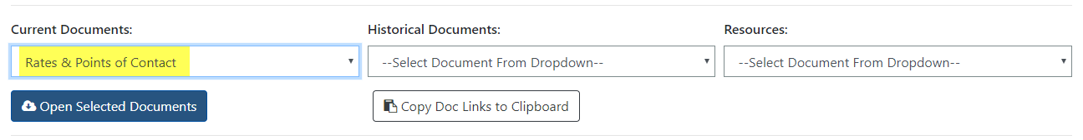
To estimate the project value take the level of effort (hours) established in Step 2 and multiply those hours by the NTE rate.

 | Example 1 | Example 2
Est. Level of Effort | 4 months (640 hours) | 1.5 weeks (60 hours)
NTE Rate | $200/hr | $200/hr
Est. Project Value | $128,000 | $12,000

Based on the Estimated Project Value, choose the appropriate option below:
Option 1 –Rapid Selection
For small projects under $10,000 (excluding sales tax) or $13,000 (excluding sales tax) if the purchase is being made from a microbusiness, minibusiness or small business as defined by RCW 39.26.010, Purchasers can select any vendor from the Tier 1 Pre-Qualified list.
When completing a rapid selection purchase it is important to select a contractor that will provide the best value to your organization. Once a vendor has been selected, complete a work order, purchase order, or similar document as required by your organization and according to your organization’s delegated authority. A sample work order is included as Attachment C – Sample Work Order in this handbook.
Note: This document is a sample and can be edited to meet your organization/project’s requirements. Requirements & recommendations for each section are included in the forms included below.
In 2017, the Office of the Attorney General requested legislation to address wage theft. SSB 5301 passed the Senate 46-3 and the House 63-33 and was signed by the Governor on May 8, 2017. See Chapter 258, 2017 Laws. The law is effective July 23, 2017. Due to the passing of this law, all contracts/work orders put into place after July 23, 2017 are required to certify compliance with wage requirements. Prior to awarding any work, ensure the vendor has completed and returned Attachment D – Wage Theft Certification.
Upon execution of the work order, work on the project may commence. Check out “NOW WHAT?” to see what document requirements, amending a work order, and rules around 2nd Tier Contracts.
If you begin a conversation with your selected vendor and discover that the work will exceed the $10,000 or $13,000 ceiling as explained above STOP! DO NOT complete the transaction and complete a 2nd Tier Solicitation (Option 2).
Option 2 – 2nd Tier Solicitation
For larger projects (over the $10,000 & $13,000 ceilings explained in Option 1) purchasers must complete a 2nd Tier Solicitation.
The process for conducting a Tier 2 Solicitation is outlined below.
- WRITE A 2ND TIER SOLICITATION DOCUMENT: Use the information gathered in Steps 1-3 to complete a 2nd Tier Solicitation Document. A sample solicitation document is included as Attachment A – Sample Solicitation Document in this handbook.
Note: This document is a sample and can be edited to meet your organization/project’s requirements. Requirements & recommendations for each section are included in the forms included below.

- POST TO WEBS: Post the 2nd Tier Solicitation Document to WEBS. There are step-by-step instructions on how to post documents in the WEBS Manual available on the WEBS website. Log in, select “View User Guides”, choose “WEBS Manual – for Gov’t customers” and follow the instructions in the “How to Post a solicitation to Notification List” section.
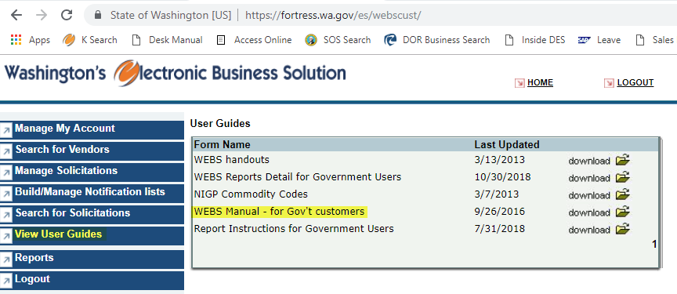 Be sure to select the notification list titled “05914 – Organizational Development” and select the following commodity codes: 918-27 Community Development Consulting, 918-75 Management Consulting, 918-83 Organizational Development Consulting, and 924-16 Course Development Services, Instructional/Training. Please include “05914 – 2nd Tier” in the Solicitation Title.

- AMEND THE WORK REQUEST (if necessary): If, after posting to WEBS, the solicitation needs to be amended, post an amendment to WEBS. The WEBS manual included in Step 2 also has instructions on how to post a solicitation amendment (see “How to Post an Amendment”). A sample solicitation amendment document is included as Attachment B – Sample Solicitation Amendment in this handbook.
Note: This document is a sample and can be edited to meet your organization/project’s requirements. Requirements & recommendations for each section are included in the forms included below.

- EVALUATE SUBMITTALS: Evaluate submittals according to the evaluation criteria posted in the 2nd Tier Solicitation Document.

- ANNOUNCE ASB: 2nd Tier Solicitations are subject to the same complaint, debrief, and protest processes as any other competitive solicitation. See the DES Policy #DES-170-00 on how to handle complaints, debriefs and protests.

- AWARD WORK ORDER (aka 2nd Tier Contract): Negotiate and execute a work order (see sample, wage theft certification, & processes explained in Option 1). Upon execution of the Work Order, work on the project may commence.

Note: The documents included in this handbook are samples and should be amended to meet the organization and project needs. Work with your internal contracts or project team to complete. DES is available for assistance.
NOW WHAT? Now that you have a work order in place, there are a couple of things to keep in mind.

Document Requirements
The solicitation and selection process must be documented and files retained for audit purposes. At a minimum, purchaser should retain a copy of:
- Posted Tier 2 solicitation document;
- Any solicitation amendments (as applicable);
- Responses submitted;
- Evaluation criteria & tools used to determine the awarded vendor;
- 2nd Tier Contract/Work Order sent to the selected vendor;
- Any additional documentation that adds clarity to the procurement.
Rules around 2nd Tier Contracts
- After the expiration or termination of the Tier 1 Master Contract, the Terms & Conditions will continue to apply to any active 2nd Tier Contracts/Workers, however:
  - New 2nd Tier Contracts/Work Orders cannot be entered into
  - Current 2nd Tier Contracts/Work Orders cannot be extended.

Contractor Management
Management of the work order lies solely with the Purchaser. Any work order changes necessary should be completed via an amendment. A sample work order amendment is included as Attachment E - Sample Work Order Amendment in this handbook.
Note: This document is a sample and can be edited to meet your organization/project’s requirements. Requirements & recommendations for each section are included in the forms included below.
Contractor Performance
Contractor performs work and submits proper invoices for payment in accordance with contract terms. Upon completion of work, Purchasers may complete a DES Vendor Performance Report Card available on the Contract Portal Page. DES may track performance for administrative purposes and share this feedback with other customers.

Updates
Date Change (Completed by)
4/11/19 Updated to address feedback and questions received. (R. Field)
10/23/17 Added information about selecting commodity codes when posting to WEBS (R. Field)
9/12/17 Added requirements around wage theft. (R. Field)

Attachment A – 2nd Tier Solicitation
Attachment B – Solicitation Amendment

Attachment C – Sample Work Order
Attachment D – Wage Theft Certification

Attachment E – Work Order Amendment

