Contract 06006- Food Umbrella Contract
Pricing and Ordering
January 2, 2019

ALL CONTRACTS UNDER 06006 ARE EXPIRED

Some have been re-awarded under new contract numbers

Awarded contractors
Category | Description | Vendor | Start Date | Current Term Expires
A1 & A3 | Frozen, Chilled, Dried & Canned: Bulk | Food Services of America -FSA | 3/21/07 | 12/31/18
C | Food Service Disposables | Veritiv Corporation dba Unisource Inc. | 10/1/07 | 9/30/18
D | Fresh Fruit and Vegetables | Charlie’s Produce (Western only);  Spokane Produce (Eastern only) | 2/1/08 | 3/31/19
E | Dairy | Meadowsweet (Olympic & NW Region),  Liberty (SW Region),  Terry’s Dairy (Eastern & N Central Region) | 9/1/07 | 3/31/17  3/31/17  3/31/17
E | Dairy | The Dairy Contract can now be found under contract number # 02016 |  | Expired

DES Contract Specialist: | Breann Aggers  Master Contracts and Consulting  (360) 407-9416  breann.aggers@des.wa.gov

PRICING & ORDERING

Category | Pricing & Ordering Information
Category A1 and A3:Frozen, Chilled, Canned & Dried (A1) Bulk (A3)  Vendor: FSA-Food Services of America  FEMA-Debarment Amendment Frozen, Chilled, Canned & Dried: Bulk | 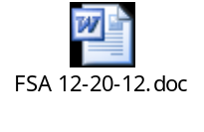
Category C: Food Service Disposables  Vendor: Veritiv Corporation dba Unisource, Inc.  FEMA-Debarment Amendment Disposables
  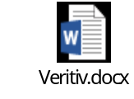
Category D:Fresh Fruit & Vegetables  Vendors:  Charlie’s (Western Region)  Spokane Produce (Eastern Region)  FEMA-Debarment Amendments Produce | 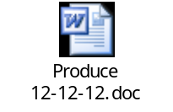
Category E:Dairy  Vendors:  Meadowsweet (Olympic & NW Region)  Liberty (SW Region)  Terry’s(Eastern & N Central Region)  Darigold (S Central Region)  FEMA-Debarment Amendments Dairy | 

