Statewide Contract 007814 – Enterprise Content Management Contract
Amendment Log

Vendor | Amendment | Amendment Description
Laserfiche | 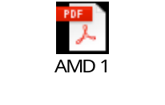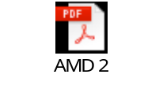    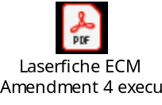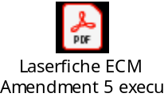  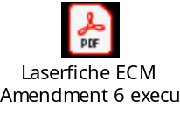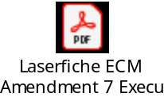  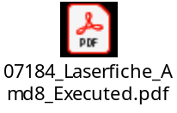 | Management fee increase  Inclusion of subscription services  Product Additions and Deletions  Contract Extension for one two (2) year term to October 25, 2022. Changing Price Adjustment Section of Master Contract to Automatic Economic Adjustment.  Contract Extension for one two (2) year term to October 25, 2024.  Contract Extension for 2 years ending 10-26-2026, addition of Non-Discrimination and Pay Equality language.  Clarification of price adjustment PPI, grant of economic price adjustment.  Amendment 8 to add Professional Services to pricelist, grant economic price adjustment, and apply product additions/deletions.
Hyland  (formerly Lexmark) | 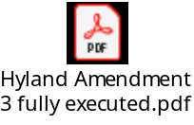  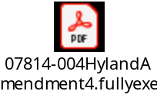 | Management fee increase  Lexmark name change to Hyland  Product Additions and Deletions  Extend Contact for a One (1) year term, ending October 25,2021. This is the final extension for this contract.
Open Text | 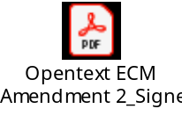  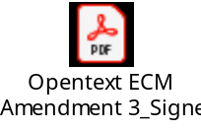  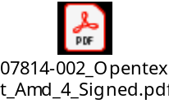  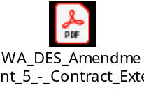  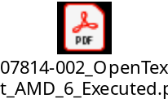  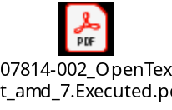  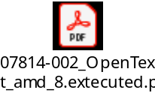  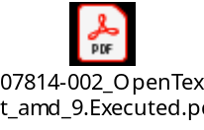  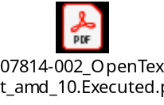 | Management fee increase  Contract Extension for one two (2) year term to October 25, 2022. In addition, Extending Price Adjustment language to max term, and clarifying Product Additions and Deletions.  Amend Section 3.3 Price Adjustments and Replace Exhibit A – Price Schedule with updated Exhibit A – Price Schedule effective 1.01.2021.  Contract Extension for one two (2) year term to October 25, 2024.  Contract Extension for 2 years ending 10-26-2026, addition of Non-Discrimination and Pay Equality language.  Contract price schedule updated, effective February 3, 2025.  Amend Section 3.3 Price Adjustments and Contract price schedule updated, effective March 13, 2026.  Amendment 8 to update price schedule, effective March 30, 2026.  Amendment 9 to update price schedule, effective June 01, 2026.  Amendment 10 to update price schedule, effective July 01, 2026.

