Cochran, Inc.

Cochran provides contract services in the following categories and regions:

Category | Region
Inside | North Puget Sound, Olympic, Southwest, North Central, Eastern

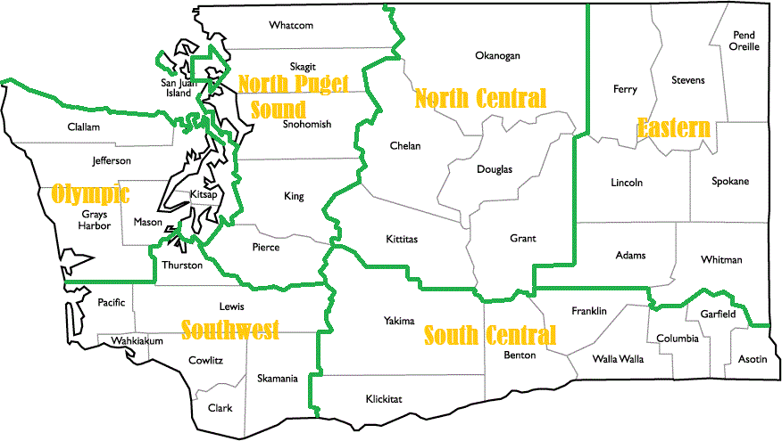

Customer service contact: | Allison Blakeley  ablakeley@cochraninc.com  206-707-3276
Main office: | Cochran, Inc.  12500 Aurora Ave. N.  Seattle, WA 98133
Cochran Pricing

