Master Contract 06419: Encampment Cleanup Services
Contractor: American Abatement & Demo

Regions served by this contractor:
Western Region – Categories 1 and 2
Central Region – Categories 1 and 2
Eastern Region – Categories 1 and 2
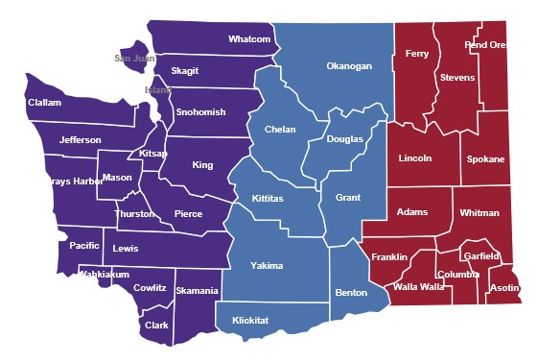
American Abatement & Demo
18855 SE Auburn-Black Diamond Rd.
Auburn, WA 98092

Customer service contact: Mari Borrero
mari@aad-wa.com
206-250-5754

American Abatement & Demo Master Contract

American Abatement & Demo is a self-certified Small Business (mini-business) per RCW 39.26.010.
American Abatement & Demo is certified as a Veteran-Owned Business by the Wash. Dept. of Veterans Affairs.
American Abatement is certified by the Office of Minority and Women’s Business Enterprises as a Minority/Women Business Enterprise.
Contract Pricing: American Abatement & Demo
There will be differences county-to-county within a region in the Department of Labor and Industries’ prevailing wage rates for jobs relevant to Contract 06419. King County, Yakima County and Spokane County are used here for example purposes only.
Column 1: These prevailing wage rates are for example purposes and apply only to the job classes listed in the tables for certain counties in the region for the current L&I prevailing wage rate table. NOTE: Prevailing wage tables are updated twice-yearly by Labor and Industries. Please check the Labor and Industries website at https://secure.lni.wa.gov/wagelookup for current wage rates.
Column 2: The contractual maximum markup percentage Contractor will apply to the then-current base prevailing wage as reflected in the official Labor and Industries wage rate tables.
Column 3: An example of the Contractor’s maximum hourly wage rate based on the contractual mark-up percentage; this rate will vary depending on the county in which contract services are performed.

Western Region
Category 1 | 1 | 2 | 3
Job | Current PW* | Markup % | Max hourly
Project manager | NA | NA | $113
General laborer | $54.62 | 50% | 81.93
Power eqpt. operator | 72.70 | 50 | 109.05
Haz. waste worker C | 54.62 | 50 | 81.93
Driver, dump truck/trailer | 64.55 | 50 | 96.83
*Based on King County

Category 2 | 1 | 2 | 3
Job | Current PW* | Markup % | Max hourly
Project manager | NA | NA | $113
General laborer | $54.62 | 50% | 81.93
Haz. waste worker C | 54.62 | 50 | 81.93
Driver, dump truck/trailer | 64.55 | 50 | 96.83
*Based on King County

Central Region
Category 1 | 1 | 2 | 3
Job | Current PW* | Markup % | Max hourly
Project manager | NA | NA | $113
General laborer | $44.12 | 50% | 66.18
Power eqpt. operator | 69.27 | 50 | 103.68
Haz. waste worker C | 44.12 | 50 | 66.18
Driver, dump truck/trailer | 51.00 | 50 | 76.50
*Based on Yakima County
Category 2 | 1 | 2 | 3
Job | Current PW* | Markup % | Max hourly
Project manager | NA | NA | $113
General laborer | $44.12 | 50% | 66.18
Haz. waste worker C | $44.12 | 50% | 66.18
Driver, dump truck/trailer | 51.00 | 50 | 76.50
*Based on Yakima County

Eastern Region
Category 1 | 1 | 2 | 3
Job | Current PW* | Markup % | Max hourly
Project manager | NA | NA | $113
General laborer | $44.04 | 50% | 66.08
Power eqpt. operator | 50.89 | 50 | 103.91
Haz. waste worker C | 44.04 | 50 | 66.08
Driver, dump truck/trailer | 49.05 | 50 | 73.58
*Based on Spokane County
Category 2 | 1 | 2 | 3
Job | Current PW* | Markup % | Max hourly
Project manager | NA | NA | $113
General laborer | $44.04 | 50% | 66.08
Haz. waste worker C | $44.04 | 50% | 66.08
Driver, dump truck/trailer | 49.05 | 50 | 73.58
*Based on Spokane County

