**Master Contract 06419:** Encampment Cleanup Services

**Contractor:** Layland Construction

**Regions served by this contractor:**

**Western Region** – Categories 1 and 2

**Central Region** – Categories 1 and 2

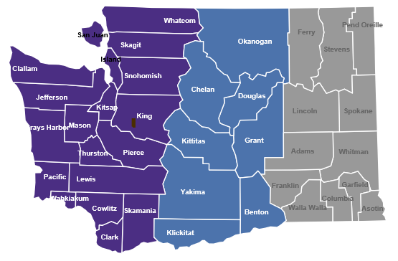

**Layland Construction LLC**

352 Kinsman Drive E.

Roy, WA 98580

**Customer service contact:**

Todd Layland

[jtlayland@yahoo.com](mailto:jtlayland@yahoo.com)

360-350-8044

[Layland Construction Master Contract](https://apps.des.wa.gov/contracting/Executed%20Master%20Contract%20Layland%20Construction.pdf?cb=10202022.1666284669318)

**Layland Construction is a self-certified Washington Small Business (microbusiness) per RCW** [**39.26.010**](https://app.leg.wa.gov/RCW/default.aspx?cite=39.26.010)**.**

**Contract Pricing:** Layland Construction

There will be differences county-to-county within a region in the Department of Labor and Industries’ prevailing wage rates for jobs relevant to Contract 06419. King County and Yakima County were used here for example purposes only.

**Column 1**: These prevailing wage rates are for example purposes and apply only to the job classes listed in the tables for certain counties in the region for the current L&I prevailing wage rate table. NOTE: Prevailing wage tables are updated twice-yearly by Labor and Industries. Please check the Labor and Industries website at <https://secure.lni.wa.gov/wagelookup> for current wage rates.

**Column 2**: The contractual maximum markup percentage Contractor will apply to the then-current base prevailing wage as reflected in the official Labor and Industries wage rate tables.

**Column 3**: An example of the Contractor’s maximum hourly wage rate based on the contractual mark-up percentage; this rate will vary depending on the county in which contract services are performed.

**Western Region**

|  |  |  |  |
| --- | --- | --- | --- |
| **Category 1** | **1** | **2** | **3** |
| **Job** | **Current PW\*** | **Markup %** | **Max hourly** |
| Project manager | NA | NA | $84 |
| General laborer | $54.62 | 60% | $87.39 |
| Power eqpt. operator | 72.70 | 60 | 116.32 |
| Haz. waste worker C | 54.62 | 60 | 87.39 |
| Driver, dump truck/trailer | 64.55 | 60 | 103.28 |

**\*Based on King County**

|  |  |  |  |
| --- | --- | --- | --- |
| **Category 2** | **1** | **2** | **3** |
| **Job** | **Current PW\*** | **Markup %** | **Max hourly** |
| Project manager | NA | NA | $84 |
| General laborer | $54.62 | 60% | $87.39 |
| Haz. waste worker C | 54.62 | 60 | 87.39 |
| Driver, dump truck/trailer | 64.55 | 60 | 103.28 |

**\*Based on King County**

**Central Region**

|  |  |  |  |
| --- | --- | --- | --- |
| **Category 1** | **1** | **2** | **3** |
| **Job** | **Current PW\*** | **Markup %** | **Max hourly** |
| Project manager | NA | NA | $84 |
| General laborer | $44.12 | 60% | $70.59 |
| Power eqpt. operator | 69.27 | 60 | 110.83 |
| Haz. waste worker C | 44.12 | 60 | 70.59 |
| Driver, dump truck/trailer | 51.00 | 60 | 81.60 |

**\*Based on Yakima County**

|  |  |  |  |
| --- | --- | --- | --- |
| **Category 2** | **1** | **2** | **3** |
| **Job** | **Current PW\*** | **Markup %** | **Max hourly** |
| Project manager | NA | NA | $84 |
| General laborer | $44.12 | 60% | 70.59 |
| Haz. waste worker C | $44.12 | 60 | 70.59 |
| Driver, dump truck/trailer | 51.00 | 60 | 81.60 |

**\*Based on Yakima County**