Master Contract 06419: Encampment Cleanup Services
Contractor: NCES

Regions served by this contractor:
Western Region – Categories 1 and 2
Central Region – Category 2
Eastern Region – Categories 1 and 2
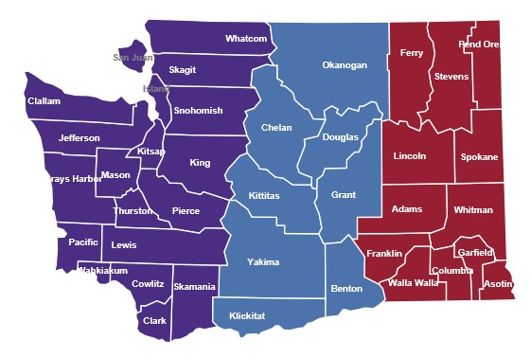
NCES, LLC
2112 E. 26th St.
Vancouver, WA 98661

Customer service contact: Eric Maughan
ericm@net-compliance.com
206-396-7190

NCES LLC Master Contract

NCES is certified by the Office of Minority and Women’s Business Enterprises as a Minority/Women Business Enterprise.
Contract Pricing: NCES
There will be differences county-to-county within a region in the Department of Labor and Industries’ prevailing wage rates for jobs relevant to Contract 06419. King County, Yakima County and Spokane County were used here for example purposes only.
Column 1: These prevailing wage rates are for example purposes and apply only to the job classes listed in the tables for certain counties in the region for the current L&I prevailing wage rate table. NOTE: Prevailing wage tables are updated twice-yearly by Labor and Industries. Please check the Labor and Industries website at https://secure.lni.wa.gov/wagelookup for current wage rates.
Column 2: The contractual maximum markup percentage Contractor will apply to the then-current base prevailing wage as reflected in the official Labor and Industries wage rate tables.
Column 3: An example of the Contractor’s maximum hourly wage rate based on the contractual mark-up percentage; this rate will vary depending on the county in which contract services are performed.

Western Region
Category 1 | 1 | 2 | 3
Job | Current PW* | Markup % | Max hourly
Project manager | NA | NA | $95
General laborer | $54.62 | 40% | $76.47
Power eqpt. operator | 72.70 | 40 | 101.70
Haz. waste worker C | 54.62 | 40 | 76.47
Driver, dump truck/trailer | 64.55 | 40 | 90.37
*Based on King County

Category 2 | 1 | 2 | 3
Job | Current PW* | Markup % | Max hourly
Project manager | NA | NA | $95
General laborer | $54.62 | 40% | $76.47
Haz. waste worker C | 54.62 | 40 | 76.47
Driver, dump truck/trailer | 64.55 | 40 | 90.37
*Based on King County
Central Region
Category 2 | 1 | 2 | 3
Job | Current PW* | Markup % | Max hourly
Project manager | NA | NA | $95
General laborer | $44.12 | 40% | $61.77
Haz. waste worker C | $44.12 | 40 | 61.77
Driver, dump truck/trailer | 51.00 | 40 | 71.40
*Based on Yakima County

Eastern Region
Category 1 | 1 | 2 | 3
Job | Current PW* | Markup % | Max hourly
Project manager | NA | NA | $95
General laborer | $44.04 | 40% | $61.66
Power eqpt. operator | 50.89 | 40 | 71.25
Haz. waste worker C | 44.04 | 40 | 61.66
Driver, dump truck/trailer | 49.05 | 40 | 68.67
*Based on Spokane County

Category 2 | 1 | 2 | 3
Job | Current PW* | Markup % | Max hourly
Project manager | NA | NA | $95
General laborer | $44.04 | 40% | $61.66
Haz. waste worker C | $44.04 | 40 | 61.66
Driver, dump truck/trailer | 49.05 | 40 | 68.67
*Based on Spokane County

