Master Contract 06419: Encampment Cleanup Services
Contractor: Totem Logistics

Region served by this contractor:
Western Region – Category 2

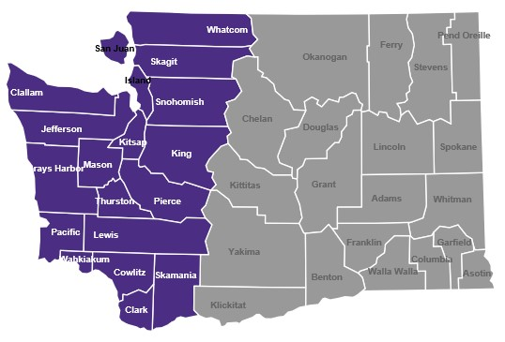

Totem Logistics
308 Clay St. NW
Auburn, WA 98001

Customer service contact:
David Scott Page
scott.page@junk-king.com
510-332-1231

Totem Logistics Master Contract

Totem Logistics is a self-certified Small Business (minibusiness) per RCW 39.26.

Contract Pricing: Totem Logistics
There will be differences county-to-county within a region in the Department of Labor and Industries’ prevailing wage rates for jobs relevant to Contract 06419. King County is used here for example purposes only.
Column 1: These prevailing wage rates are for example purposes and apply only to the job classes listed in the tables for certain counties in the region for the current L&I prevailing wage rate table. NOTE: Prevailing wage tables are updated twice-yearly by Labor and Industries. Please check the Labor and Industries website at https://secure.lni.wa.gov/wagelookup for current wage rates.
Column 2: The contractual maximum markup percentage Contractor will apply to the then-current base prevailing wage as reflected in the official Labor and Industries wage rate tables.
Column 3: An example of the Contractor’s maximum hourly wage rate based on the contractual mark-up percentage; this rate will vary depending on the county in which contract services are performed.

Western Region

Category 2 | 1 | 2 | 3
Job | Current PW* | Markup % | Max hourly
Project manager | NA | NA | $95
General laborer | $54.62 | 70% | 92.86
Haz. waste worker C | 54.62 | 70 | 92.86
Driver, dump truck/trailer | 64.55 | 70 | 109.74
*Based on King County

