Master Contract 06419: Encampment Cleanup Services
Contractor: WFS Environmental

Region served by this contractor:
Eastern Region – Category 2
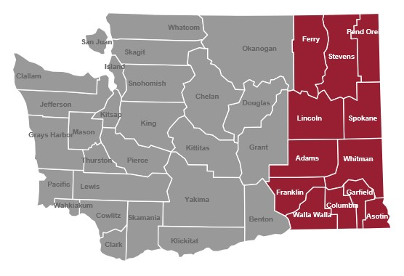
WFS Environmental
3505½ Fruitvale Road
Yakima, WA 98902

Customer service contact:
Tim Logozzo Sr.
wfstim@gmail.com
509-453-3473

WFS Environmental Services Master Contract

WFS Environmental is a self-certified Small Business (microbusiness) per RCW 39.26.010.

Contract Pricing: WFS Environmental
There will be differences county-to-county within a region in the Department of Labor and Industries’ prevailing wage rates for jobs relevant to Contract 06419. Spokane County is used here for example purposes only.
Column 1: These prevailing wage rates are for example purposes and apply only to the job classes listed in the tables for certain counties in the region for the current L&I prevailing wage rate table. NOTE: Prevailing wage tables are updated twice-yearly by Labor and Industries. Please check the Labor and Industries website at https://secure.lni.wa.gov/wagelookup for current wage rates.
Column 2: The contractual maximum markup percentage Contractor will apply to the then-current base prevailing wage as reflected in the official Labor and Industries wage rate tables.
Column 3: An example of the Contractor’s maximum hourly wage rate based on the contractual mark-up percentage; this rate will vary depending on the county in which contract services are performed.

Eastern Region
Category 2 | 1 | 2 | 3
Job | Current PW* | Markup % | Max hourly
Project manager | NA | NA | $150
General laborer | $44.04 | 125% | $99.09
Haz. waste worker C | 44.04 | 125 | 99.09
Driver, dump truck/trailer | 49.05 | 125 | 110.36
*Based on Spokane County

