Line Item Upload Template
The following Excel template can be used to upload line items into the Surplus Property Request System.
Multiple spreadsheets can be uploaded to each request document.
A copy of the template and a Category/Sub-Category Report is available on the Main menu.
The report can be used to help determing the correct category codes.
The Category/Sub-Category Report can be exported to Excel to save for future reference.
Field Information
Field Name | Data Type/Length | Comments
CATEGORY_CODE | Numeric | See Category/Sub-Category Report
SUB_ CATEGORY_CODE | Numeric | See Category/Sub-Category Report
QUANTITY | Numeric
TAG_NUMBER | Text 12 characters maximum
DESCRIPTION | Text 75 characters maximum
SERIAL_ID_NUMBER | Text 25 characters maximum
ESTIMATED_VALUE | Text 20 characters maximum | Number or currency format recommended
FUND | Text 10 characters maximum
NOTE | Text 25 characters maximum | Can be used as a reference field

Not all fields are required for each line item. The following fields are recommended for each line item.
- Category Code
- Sub-Category Code
- Quantity
- Description
All other fields can be supplied as needed for your organization.

Saving the template for uploading
After completing the template, the spreadsheet needs to be saved as a TAB Delimited file for uploading.
The TAB Delimited option is available when using the File Save As menu commands.

Uploading line items with tab-delimited file.
1. Create a standard request and complete the contact and address information.
2. To upload line items, click the “Upload Items” button on the lower right of the screen.
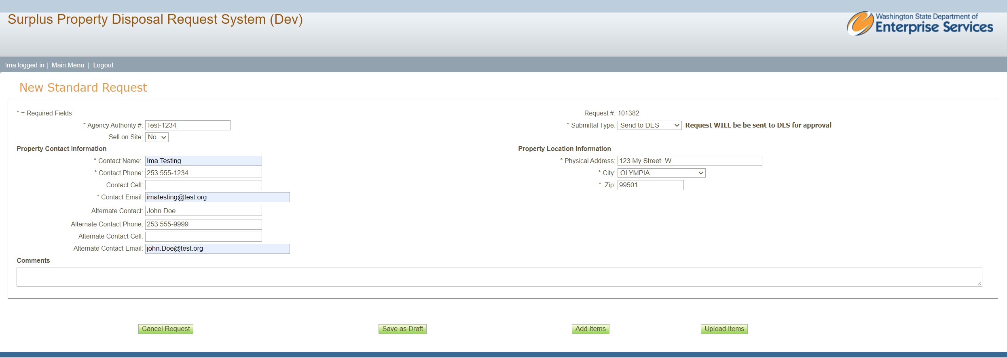
The button will open a shaded panel.
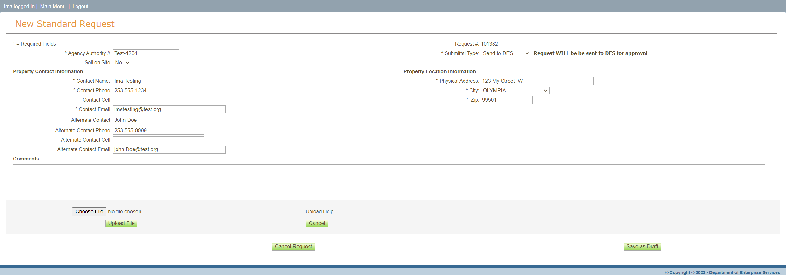

3. Click “Choose File” to select your tab-delimeted file.
File Explorer will open and allow you to select your upload file.
4. Click “Upload File” to upload your file.
A message will confirm that your file has been uploaded and is ready to process.
4. Click “Add Line Items” to process your file.
Line items will appear above the upload panel after processes.
A message will confirm the number of line items uploaded.
Please be patient for the file to complete processing.
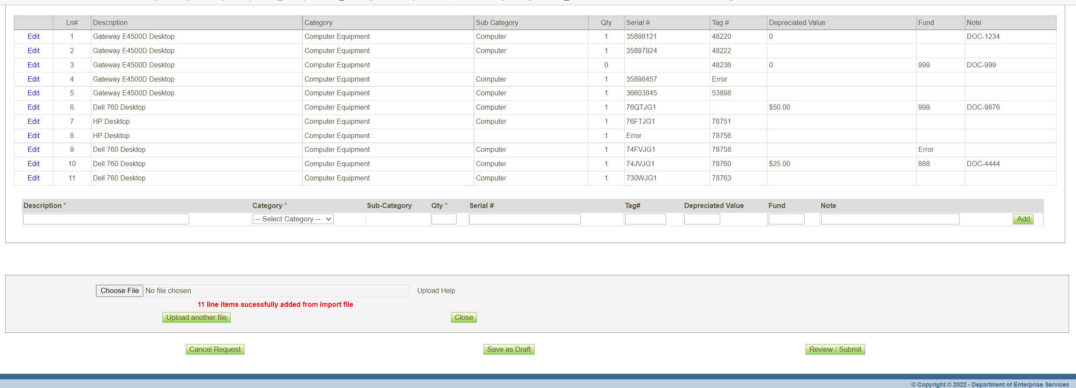
After successfully uploading line items, the items can be edited if needed.
Additional line items can be added manually, or another file can be uploaded.
There is no limit to the number of files that can be upload.
After saving request as Draft, additional line items can be uploaded when returning to the request for review or editing.

